

Mechatronics Lab Safety Report

Testing of a Tip-Thrust Rotary Aircraft

|  |  |
| --- | --- |
| **Date:** | 23/09/2024 |
| **Student & SU nr:** | Rayde Krüger 24723061 |
| **Student contact nr:** | 063 694 9735 |
| **Supervisor:** | Dr Andrew Gill |
| **Lab engineer:** | Mr Ferdi Zietsman |
| **Head of safety:** | Mr Cobus Zietsman |

Emergency Contacts:

|  |  |  |  |
| --- | --- | --- | --- |
| **Contact:** | **Room nr.** | **Work nr.** | **Cell nr.** |
| Mr F. Zietsman | 109 | - | 021 808 4954 |
| Mr C. Zietsman | M212 | 021 808 4275 | - |
| Campus Security | - | 021 808 2333 | WhatsApp:  082 808 233 |
| Fire Brigade | - | 021 808 8888 | - |
| Ambulance | - | 021 883 3444 | - |

Signatures:

|  |  |
| --- | --- |
| Student:  (Rayde Krüger) |  |
| Supervisor:  (Dr A. Gill) |  |
| Lab Engineer:  (Mr CF. Zietsman) |  |
| Head of Safety:  (C Zietsman) |  |

**Pressure vessels or pipes (check relevant box):**

No pressure vessels or pipes with pressure in excess of 50kPa are involved in this project.

Pressure vessels or pipes in excess of 50kPa are involved – additional signature and report required (refer to Safety Report Guidelines on SUNLearn).

**Hot work / working at heights / confined entry / excavation (check relevant box):**

No hot work / working heights / confined entry / excavation work involved in this project.

Hot work / working heights / confined entry / excavation work (underline relevant work type(s)) involved in this project – additional signature and report required (refer to Safety Report Guidelines on SUNLearn).

**Overview of Testing**

Type of test and standard (if applicable):

|  |  |
| --- | --- |
| **Test type** | Testing of tip-thrust rotary aircraft |
| **Standard(s)** | IEC 60950-1 / IEC 62368-1: |

Equipment to be used:

|  |  |  |  |
| --- | --- | --- | --- |
| **Equipment type** | **Make & model** | **Measurement range (if applicable)** | **Resolution (if applicable)** |
| 40 A DC power supply | - | - | - |
| Oscilloscope | - | - | - |
| Soldering Iron | - | - | - |
| Load Cell 50KG | TAL220 Series | 0 to 50 kg | - |
| Load Cell Amplifier | HX711 | - | 24-bit |

**Detailed Experimental Procedure**

The purpose of this section is to clearly communicate the purpose of equipment use and list the steps necessary to prepare the equipment for testing. This report will describe the testing of a tip-thrust rotary aircraft, and the risks associated with them. The purpose of the testing will be to determine the behaviour of the system’s rotor, the amount of thrust produced, and if directional thrust can be achieved.

**Pitch control testing setup:**

* Assemble the rotary wing aircraft
* Secure the rotary wing aircraft to the base
* Secure the rotor hub so it cannot rotate
* Ensure the correct voltage is being supplied by the power supply
* Connect the power supply to the hub
* Identify the emergency stop button (Power supply off switch)
* Ensure all the components have been correctly wired
* Ensure all wires, loose items or clothing are clear of the motors

**Pitch control testing procedures:**

* Switch on the power supply
* Ensure the hub is secure and there are no obstructions in its path in the event that it comes loose and rotates
* Calibrate the pitch sensor of the rotor
* Activate the tip-thrust motors on low-speed
* Slowly increase the thrust until the desired speed of the tip thrust motors, ensuring that the hub remains stationary
* Once the rotor is stable, set a target pitch for the PID controller to reach
* Change the target pitch multiple times to determine the response speed for the different pitch values.
* Record the results in an Excell spreadsheet
* Switch off the tip-thrust motors and repeat the experiment

**Directional thrust testing setup:**

* Assemble the rotary wing aircraft
* Secure the rotary wing aircraft to the base
* Ensure there are no obstructions in the rotor's path
* Ensure all components are securely attached to the aircraft
* Connect the load cells to the DAQ and ensure they are being received
* Calibrate the load cells using known weights
* Ensure the correct voltage is being supplied by the power supply
* Identify the emergency stop button (Power supply off switch)
* Ensure all the components have been correctly wired
* Connect the power supply to the hub
* Ensure all wires, loose items or clothing are clear of the motors

**Directional thrust testing procedure:**

* Switch on the power supply
* Calibrate the rotor pitch sensor
* Ensure that the rotor path is clear of any obstructions before switching on the tip-thrust motors on low-speed
* Set the target angular velocity of the rotor
* Wait until the angular velocity has become steady
* Record the response of the control system
* Record the data from the load cells
* Set directional flight mode
* Record the data from the load cells
* Repeat the experiment for different angular velocities and directions

**Shut down procedure:**

* Stop the software of the microcontroller and ensure all components are in a state to power down
* Turn off the power supply
* Wait until all components have stopped moving
* Remove the rotary wing aircraft from the base
* Disassemble components to fit into storage
* Remove the load cells
* Safely store components
* Clean up workstation

**Warning Symbols**

(a) Electrical hazard (b) General Warning (c) Rotating machinery warning

Figure 1: Applicable warning/hazard symbols

**General Laboratory Safety**

The following general laboratory safety instructions are applicable:

* No afterhours testing may be performed without the necessary permissions[1].
* Full supervised training is required before testing may be undertaken. Permission to proceed with unsupervised testing should be signed off by the lab engineer.
* Closed shoes must be worn at all times.
* Emergency equipment must be located and easily accessible.
* Students may not work alone in the laboratory.
* Emergency exits must be known. The nearest exits applicable to the setup are provided in Appendix A of this document
* Loose clothing may not be worn. Loose hair must be tied up.
* Good housekeeping practices should be maintained during testing. The lab should be completely clean, including all equipment stored away, after testing. Refer to the General Housekeeping section for particulars regarding practices to be followed for this specific setup.
* No food or drink is permitted in the laboratory.
* Safety report must be visible and accessible during testing.
* No equipment or test may be left unattended.

**Anticipated Interactions with Other Laboratory Users**

Barriers between the rotary wing aircraft and other nearby projects to reduce the risk of components falling off and striking another student or their project.

**General Housekeeping**

* Keep workspace tidy while working
* Switch off power supplies after use
* Disassemble the rotor and place it in its storage
* Clean working surface, remove any debris and off cuttings
* Return all equipment to their storage
* Ensure the workstation is clear and clean
* Ensure no personal items are left behind

**Fire Safety**

The DC motors could potentially overheat. This can be avoided by ensuring the motors operate below the maximum operating voltage, ensuring that they do not overheat. Parts of the circuit could short and cause a fire. This hazard can be mitigated by using properly insulated wires and labelling the wires, so wires aren’t incorrectly connected and by having neat solders. In case of a fire, the evacuation plan can be seen in Appendix A. No earphones should be worn while working so fire alarms can be heard.

**Activity Based Risk Assessment**

|  |  |  |  |  |
| --- | --- | --- | --- | --- |
| **Activity** | **Risk** | **Risk Type* (P/E)** | **Mitigating Steps** | **Classification of Risk Severity** |
| GENERAL | | | | |
| Moving around the lab | Tripping or knocking over equipment | P | Be aware of the surrounding equipment and environment when walking in the lab | Acceptable risk |
| Power outages | Data loss and damage to equipment | E | Check the loadshedding schedule beforehand | Possible risk |
| Personal items | Theft of items | P | Don’t leave personal items unattended | Acceptable risk |
| TESTING PHASE | | | | |
| Installing electrical components | Electric shocks | P | Ensure the power is off when working with the components | Possible risk |
| Shorting electrical components | E | Ensure all components are connected correctly before powering them | Acceptable risk |
| Incorrect connections | E | Ensure components are connected according to the wiring diagram | Acceptable risk |
| Using hand tools | Injuries due to slippage | P | Ensure if a tool slips, no injuries can occur | Acceptable risk |
| Installing motors | Dropping motors | E | Handle motors with care | Acceptable risk |
| Assembling rotor | Pinching fingers | P | Ensure fingers are not caught in between components while assembling | Acceptable risk |
| Incorrect Calibration | Aircraft is uncontrollable | P/E | After calibrating the pitch, ensure the readings are correct | Acceptable risk |
| Loose wires or clothing caught in the motors | Getting items entangled by the motors | P/E | Don’t wear loose clothing and ensure any loose items are kept away from the motors | Acceptable risk |
| Rotor turning | Impact with the rotor | P/E | Ensure there are no obstructions with the rotors’ path | Possible risk |
| Items detach from the rotor | P/E | Check that all items are securely attached to the rotor and hub | Possible risk |
| Rotor turning | Rotary aircraft tips over | P/E | Ensure the base is firmly secured | Possible risk |
| Load cell failure | Incorrect readings from the load cells | E | Calibrate the load cells before use | Acceptable risk |
| Testing motor | Motors overheat | E | Ensure the motors operate within the rated values | Acceptable risk |
| Burns occur from motor overheating | P | Ensure the motors operate within the rated values | Acceptable risk |
| Testing software | Code not working as intended | P/E | Ensure the code is fully understood before it is uploaded | Acceptable risk |
| Backing up data | Data loss | E | Use a USB/ hard drive which is frequently updated. | Acceptable risk |

*P – personal, E - equipment

**Disciplinary Actions**

Failure to comply with any of the aforementioned safety regulations or procedures will result in disciplinary action. Students will be issued an initial warning: after three warnings, the lab access is revoked for a month.

**Appendix A: Emergency Evacuation Plans**

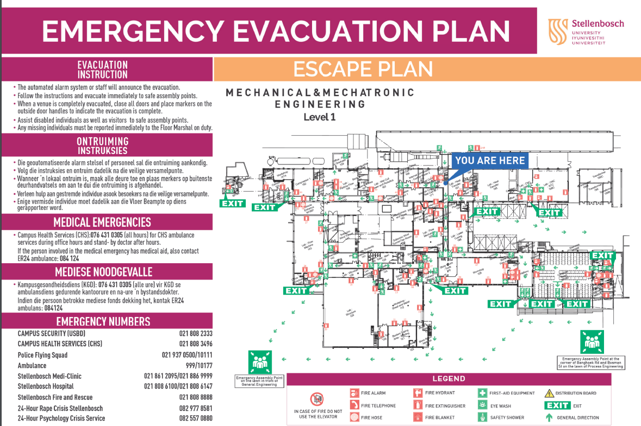

1. Written permission from supervisor and approved by the chief safety officer. Attach proof of this permission to this document and note here the times and conditions of the arrangement.